**DAILY ONLINE ACTIVITIES SUMMARY**

|  |  |  |  |  |  |  |  |  |
| --- | --- | --- | --- | --- | --- | --- | --- | --- |
| **Date:** | **13/06/2020** | | | | | **Name:** | **SUJANA** | |
| **Sem & Sec** | **IV sem & B section** | | | | | **USN:** | **4AL18CS089** | |
| **Online Test Summary** | | | | | | | | |
| **Subject** | | **Data Communication** | | | | | | |
| **Max. Marks** | | **30** | | **Score** | | | **20** | |
| **Certification Course Summary** | | | | | | | | |
| **Course** | **Introduction to Ethical Hacking** | | | | | | | |
| **Certificate Provider** | | | **Greatlearning academy** | | **Duration** | | | **4.0 hours** |
| **Coding Challenges** | | | | | | | | |
| **Problem Statement1:** Write a C Program to calculate Electricity Bill.  **Problem Statement2:** How to find the first non-repeated character of a given String in java. | | | | | | | | |
| **Status: Executed** | | | | | | | | |
| **Uploaded the report in Github** | | | | | **YES** | | | |
| **If yes Repository name** | | | | | **Online-coding** | | | |
| **Uploaded the report in slack** | | | | | **YES** | | | |

Online Test Summary: 18CS46 test was scheduled from 2:00pm t0 2:30pm .The portion for the IA was 1st and 2nd module there were 30 questions and the time assigned was 30 minutes the questions were mcq type.

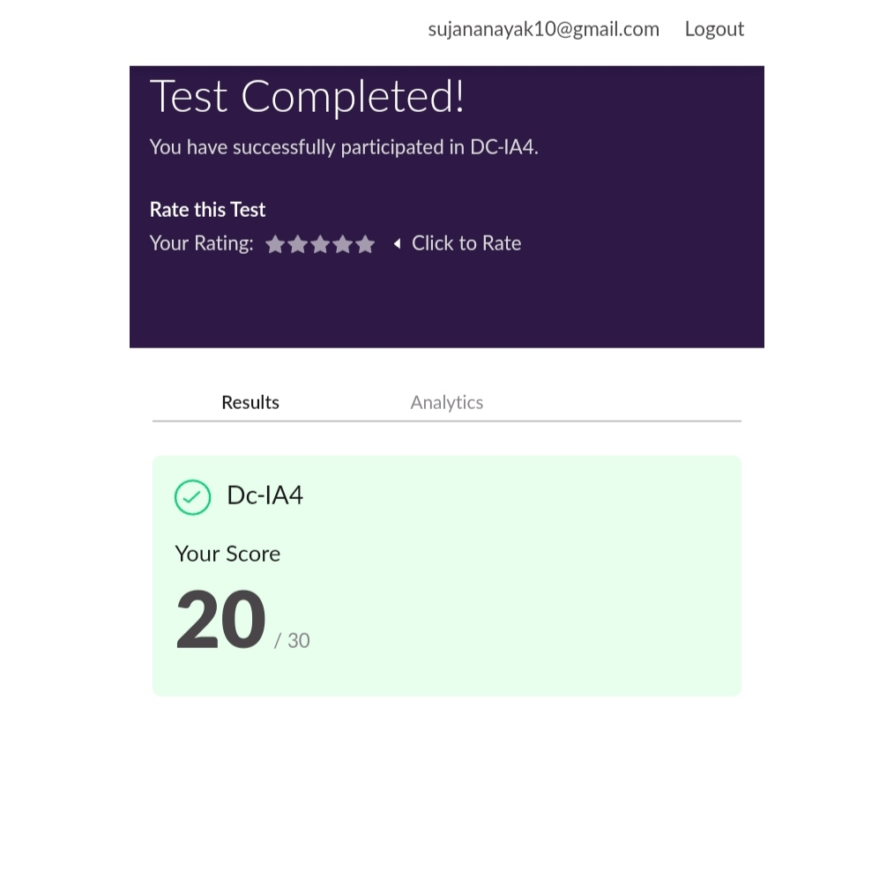

This is the completion of test and marks obtained for 18CS46.

Online Certification Course Summary: In today’s session I have learnt about the Ethical Hacking on Mobile Platforms and also came to know about demonstration that is done in android systems and iOS phones.

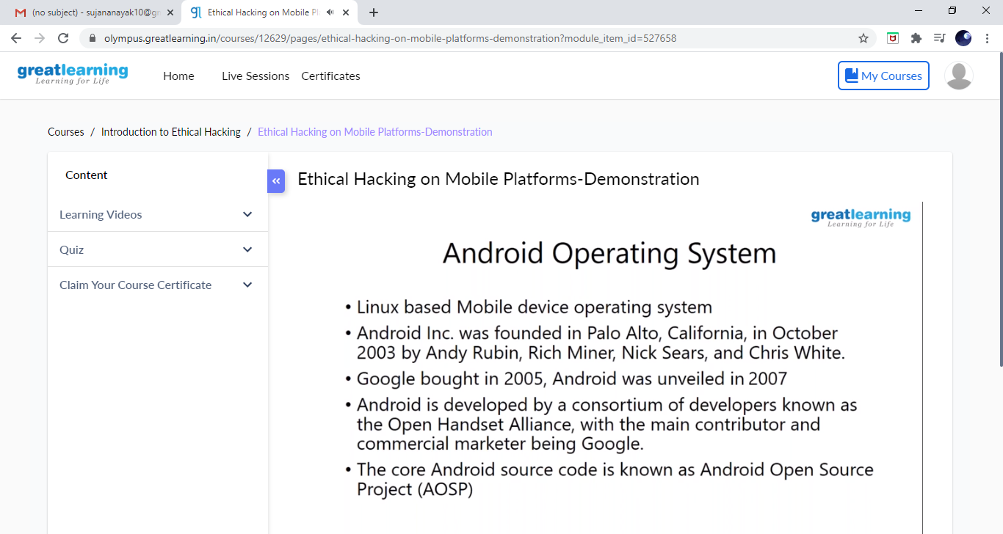

These is the Snap Shot of today’s session.

Online Coding Summary: **Today I had received one program from prof. Vasudev CSE Dept. and prof.Venkatesh CSE Dept. The program is mentioned above in the coding challenges(pg.01). I have also uploaded it to my Github repository.**

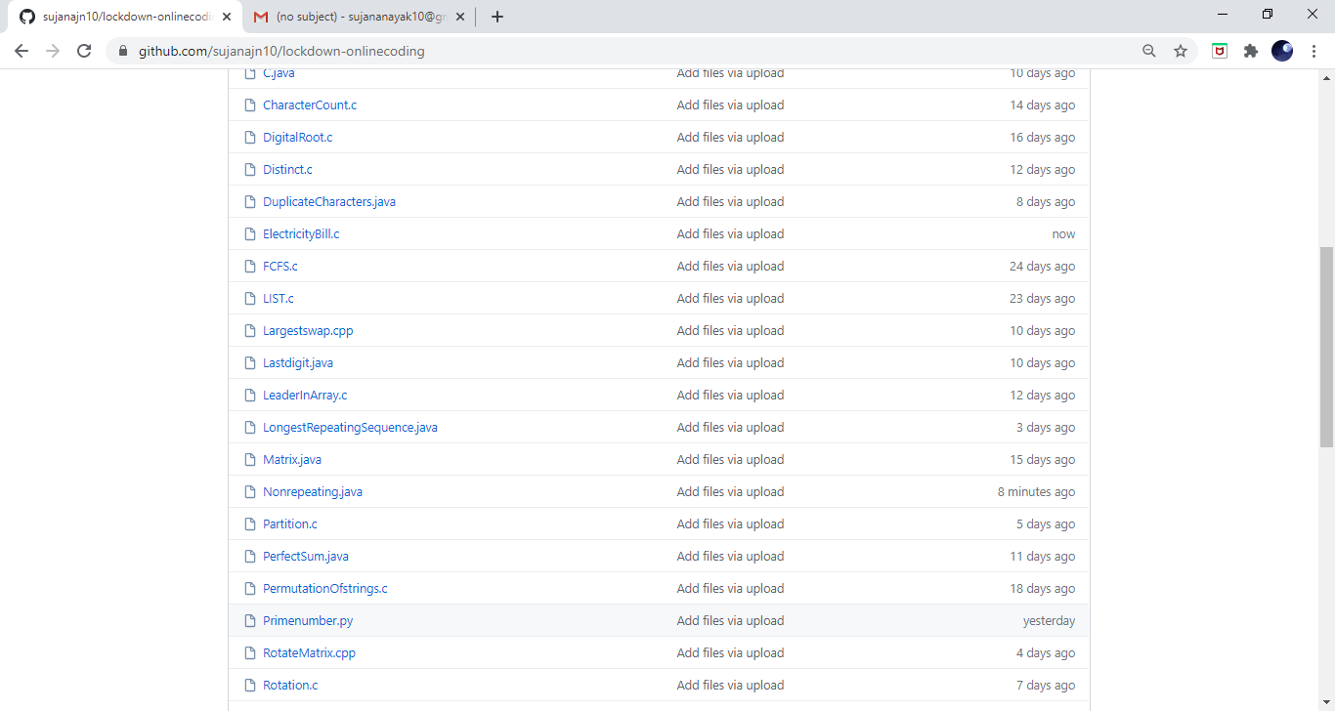

**This is the snap shot of my Github repository** were I have uploaded the code. File name is Electricitybill.c and Nonrepeating.java